CEDAR VALLEY ARBORETUM AND BOTANIC GARDENS AT HAWKEYE COMMUNITY COLLEGE IN RETROSPECT
By Paul Kammerdiner
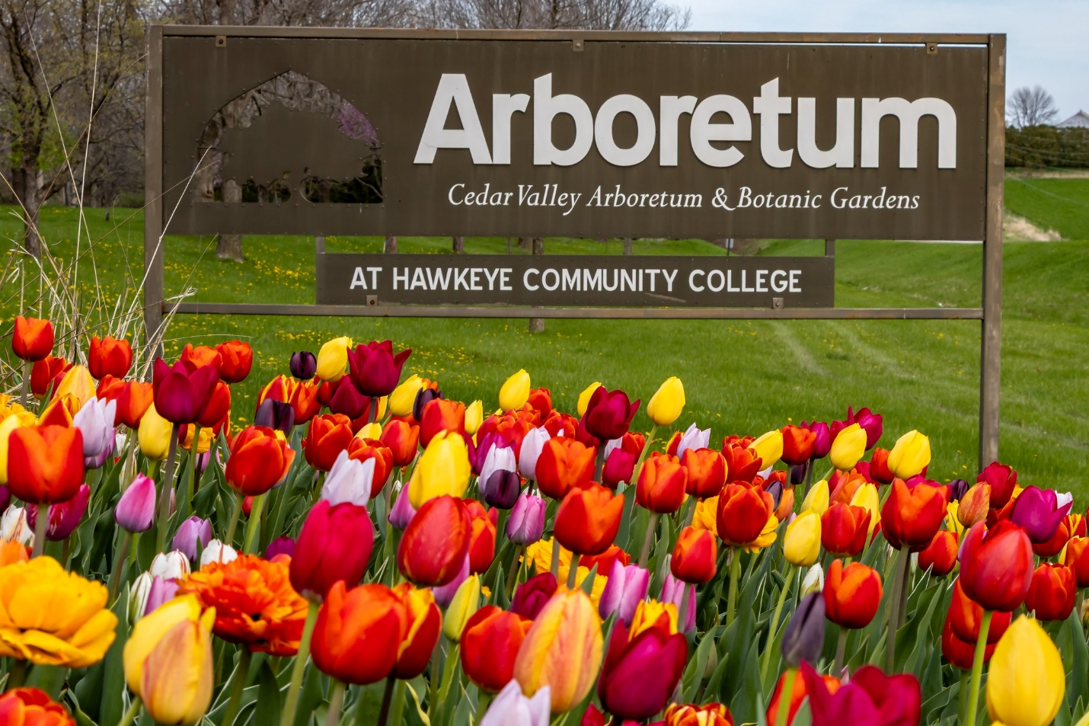
This year we will celebrate the 30th anniversary of the founding of our gardens and marvel once again at this remarkable story. But first least there be any confusion a word of explanation. We have updated our website again and as in the past, the history piece has been lost. So once more I will attempt to recreate it. I thought I would take the opportunity to change it up a bit by sort of merging all the previous versions into this one. I hope you enjoy it.
My task as before is to document the on-going story of a place. To call this a history would put too fine a point on it. I want this to be about the people associated with this place. History is too finite a term as this story is still evolving. As we journey along, we will, indeed, learn about the beginnings, but I hope we will see the people as well. Perhaps we will discover things we didn’t know before, but the story is all important and the story is always about the people. Beginning in 1995, a group began to transform a livestock pasture and corn fields into an Arboretum and Botanic Garden, the first, and still the only one in our immediate area. Along the way new people have joined in, as some are no longer involved for all of life’s varied reasons. It is my hope that the story will always be on-going.
There is no special agenda here. The older information came from documents and photos found crammed in old file cabinets in the barn. I have done my best to assure that the information is correct, however, there may well be inaccuracies, they are not intentional. There are some assumptions made from the pictorial record and again these may not be accurate, however, whenever possible, I used what notes are with the photos and such documents I could find. The purpose is to make as cohesive an account as these sources allow. If there are names on the pictures, I will include them, but there will be many people in the photos that I don’t know and are not named. I want to show them anyway, let me re-emphasize my first point, this is a story and stories need to be about people. If you recognize yourself or someone you know and they, or you, are not named, it is because I don’t have that information, forgive me for that, no slight is intended.
The format style is on purpose; that is, some verbiage interrupted by photos, sometimes, the pictures are the narrative, so there are some groups of photos within the headings that are self-explanatory. At times I will make comparisons of the historical record to present day, mostly so those readers whom may be new to the Arboretum can gain some perspective and also because it is fun to see how far we have come. For reference; whenever you see CVABG, I am referring to the Cedar Valley Arboretum and Botanic Gardens.

AT FIRST AN IDEA
According to an interview with Jan Guthrie and Maurine Crisp; in the late 1980’s local gardening enthusiasts Dick Meyerhoff and Fred Button suggested starting various clubs throughout the Cedar Valley devoted to growing things. They would include organizations like the Men’s Garden Club, the African Violet Club, and the Herb Club. Then in 1994, according to a document in our records titled; Cedar Valley Botanical Garden Proposal, a concept was being developed to combine these activities into an actual public space. The organizers listed on this document are; Kelly Conrad, Tom Lawler, and Ron Camarata.
This concept was later modified and others contacted such as; Waterloo and Cedar Falls Parks Departments, Cedar Valley Men’s Garden Club, UNI Preserve Alliance League, the Herb Club, Hawkeye Community College, Iowa State Extension, Harmony House Horticulture Program, and Green Scene.
A DREAM
1995
This is a year for laying the groundwork for the realization of the dream.
- A task force is formed to further develop the idea of a public green space in the Cedar Valley. This task force included; Charles Lott, Kelly Conrad, Joy Swartz, Jolene Rosauer, Rosemary Beach, Jan Guthrie, Craig Gibleon, Wanda Sauerbrei, Leila George, and Maurine Crisp.
- An agreement is reached with Green Scene to use their non-profit status to begin to fund raise and create public awareness of the desire to create the Arboretum. In exchange the Arboretum would provide space for Green Scene to keep plant material.
- A town hall meeting is held March 27, 1995 to gain public interest. Approximately 100 people attend.
- In April of the same year a newsletter is sent out via Green Scene introducing the concept of an Arboretum.
- By May a site selection team is actively considering six sites that have been offered and they tour the land offered by Hawkeye College.
This site consists of 74 acres of what was a cow pasture. There are a few small groups of Honey Locus trees on the site but most of it is open grassland with Sink Creek running through a section in the Eastern corner.
It is bounded to the South by East Orange Road and to the East by Hess Road. The site is adjacent to Hawkeye Community College to the West.

- 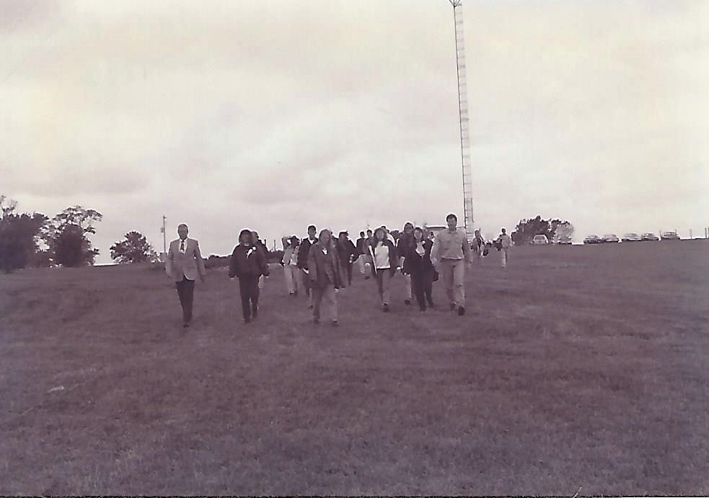

This is the site selection team walking the site proposed by Hawkeye Community College.
- With the encouragement and enthusiastic help of Dr. Berry, President of Hawkeye Community College, the 74-acre plot owned by the college is selected.
- 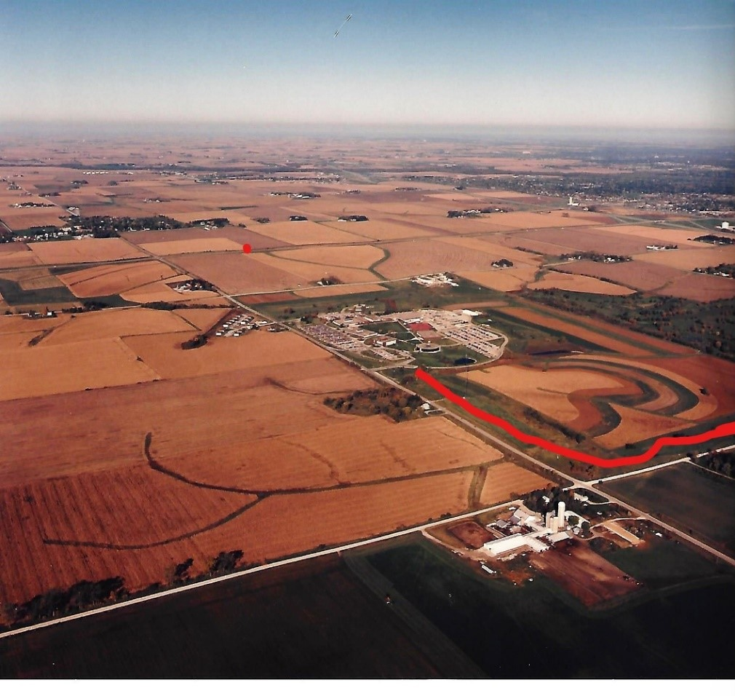
This aerial view shows the college buildings just above a spot with a red line around it. Within that line is 74 acres which will become the CVABG.
- By the summer of 1995 Tom Lawler an attorney from Parkersburg has assisted in the signing of a 99-year lease with the college. In September the Cedar Valley Arboretum and Botanical Garden at Hawkeye Community College receives its own non-profit organization status.
If you remember one of the original “idea” people is Dick Meyerhoff. I found a little gem in our records. It is a newsletter (I think from Green-Scene), I found this quote from it very interesting “Several years ago, after a trip to the Dubuque Botanical Gardens, Dick asked the question, why not here? One of the first stages in the development of the Cedar Valley Arboretum and Botanic Garden occurred when Dick organized the Cedar Valley Herb Club and African Violet Club. He believed that garden enthusiasts would assist in building support for the Cedar Valley Arboretum and Botanic Garden.”
It turns out he was right and in October of 1995 an offical ground breaking ceremony was held on the site.
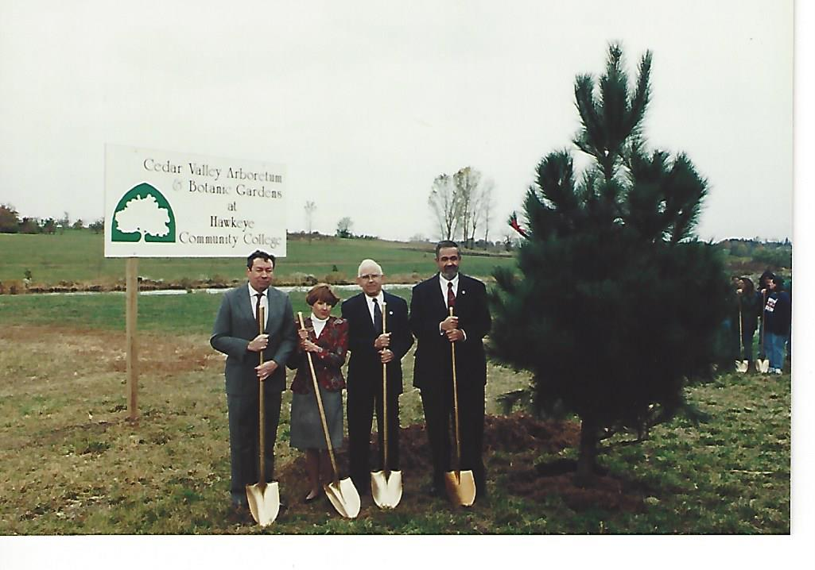
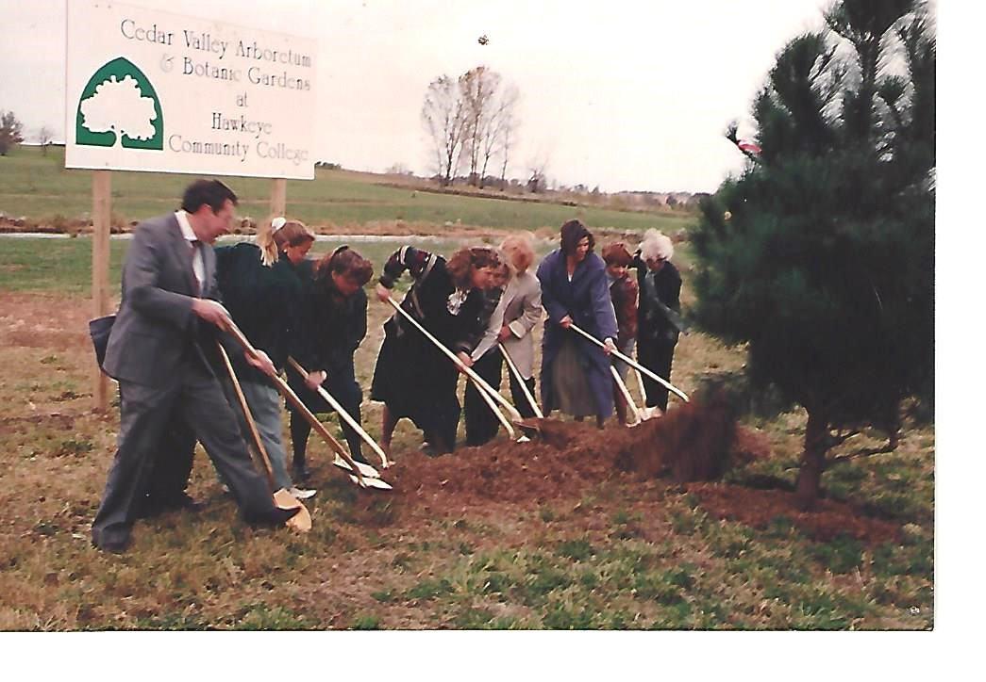

As part of that ceremony the first tree was planted on site and CVABG is born.

